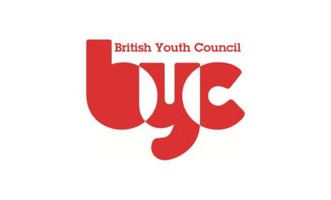
School Nurse Champion Award - Submission and Moderation Form

Please complete this form at the time of submission of young people’s logs book. We will invoice for the full amount depending on membership status of BYC.

Once payment has been received the internal and external moderation process will begin.

○ £20 BYC Member Rate (Per Person) ○ £30 Non-Member Rate (Per Person) ○

Organisation :
Contact and Address: (where certificates should be sent): |  |  |  | Postcode:
Contact and Address: (where invoice should be sent if different from above) |  |  |  | Postcode:
Purchase order number (if required)
Candidate Details
CANDIDATE NAME  Print name in CAPITAL LETTERS as required on certificate |  |  |  |  | DATE OF BIRTH  DD/MM/YYYY
1.
2.
3.
4.
5.
6.
7.
8.
"I confirm that the above portfolios have been produced by young people meet the required standards."
Name: |  |  | Signature: |  |  | Date:
To be signed by BYC representative only:
"The above listed portfolios have been Externally Moderated and meet the required standards."
Signed: Date:

