Written evidence submitted by Education and Employers (BYC047)
A. Why is work experience so important?
One of the primary purposes of work experience has long been seen as providing young people with opportunities to explore different jobs and so make better decisions about their occupational ambitions. In the past years the research team at Education and Employers evidenced the value of work experience in several publications and consultations. We heard from teachers and young people in a number of surveys and the findings of which is summarised below:
- Work experience and economic outcomes
In the report Contemporary transitions: Young Britons reflect on life after secondary school and college we set out findings from a survey of 1,744 young British adults aged 19-24. The survey undertaken on behalf of Education and Employers by YouGov investigates the experiences of respondents as they engage in transitions which take them from education towards the working world. One of the major findings was that young people who have done work experience were almost 40% less likely to be NEET on the day of the survey comparing to their peers who didn’t do a work experience between the age of 14 and 16. Similar result emerged when we looked at the experiences of those aged 16-19 which emphasises on the importance of school-mediated work experience as well as post-16.
In the same study we asked young people about the volume of employer engagement activities they have been involved in including work experience and those who had higher volume of experiences of the world of work earned more than their peers who had less experiences. This relationship is also found in another journal article from our research team in 2013 which suggests a link of 4.5% between each additional school-mediated employer contact.
- Work experience and education outcomes
Focus group research with teachers highlights two primary means by which spells of work experience can influence improved attainment. Firstly, there is a sense that work experience can provide an environment which helps to contextualise classroom learning. Secondly, and more importantly, work experience is seen as a ‘wakeup call’ providing young people with powerful evidence that education and qualifications are of high value in the labour market. In this way, work experience can be seen as a means of motivating young people to apply themselves more assiduously to their studies. In 2008, some 15,000 young people aged 15 and 16 completed a questionnaire after returning from work experience placements. An overwhelmingly majorities felt that the experience had led to a change in their attitudes towards schooling.

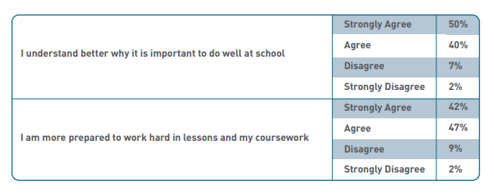
Pupil perceptions on work experience following their placement. NEBPN survey of 15,025 young people, 2008

A 2012 survey of teaching staff undertaken pro bono by the National Foundation for Educational Research (NFER) on behalf of the Education and Employers approached the same question from the perspective of teaching staff. Based on survey responses from more than 700 teachers with experience of teaching at Key Stages four and five, nearly two-thirds agreed that young people returned from work experience placements better motivated to do well at school.
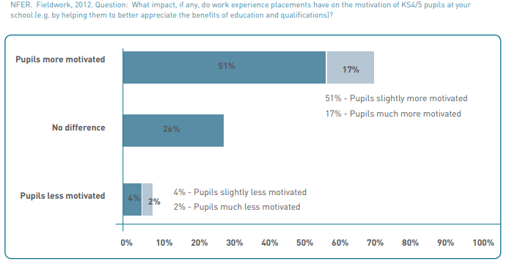
Within this consideration of the link between work experience and attainment, it is important to consider the opportunity cost involved. In essence, does going on a placement actually reduce the exam success of pupils? Available evidence would suggest that this is occasionally, but rarely the case. In the NFER survey, fewer than five per cent of teachers thought that placements would reduce the motivation of pupils or their ability to reach attainment targets. A 2008 literature

review, commissioned by the then Department for Children, Schools and Families looking at high quality research into the link between business engagement with schools found, moreover, that no evidence could be found of achievement reducing as a result of employer engagement activities such as work experience.

- Work experience and employment outcomes
The argument for work experience placements making a difference in the labour market has largely focused on its assumed ability to develop what are widely known as ‘employability skills’. Being the largely softer skills which allow an individual to be personally effective in the work they do, ‘employability skills’ have been defined in many different ways by governments, employers, educational institutions and other commentators.
In 2008, some 15,000 young people gave their views about the extent to which the work experience placements they had undertaken helped them develop their work readiness. Designed in part as a test of employability skills accumulation, the survey found large numbers of young people testifying to the opportunities presented by work experience to develop these skills as well as increasing understanding of what those skills are.

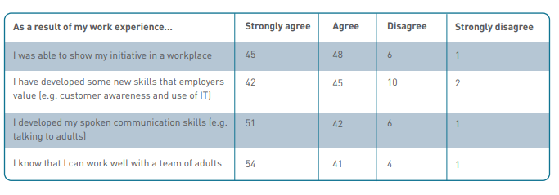
Pupil perceptions on work experience following their placement. NEBPN survey of 15,025 young people, 2008

B. What evidence is there that work experience boosts social mobility? And How could schools and colleges be better supported to help their students access quality work experience?
Work experience is often seen as a very effective means to broaden the career aspirations of pupils. The authenticity of the experience and opportunity to investigate the breadth of professional areas provide rare and valuable resources to young people. However, young people need to access the experience in order to gain from it. The career ambitions of young people emerge out of their specific social contexts shaping the extent to which different occupational areas are appropriate or not for ‘people like me’.

Work by sociologists and educationalists highlights the ways in which social class, gender and ethnicity often limit ambitions, regardless of aptitude. In such a context, work experience can often be a powerful means to challenging stereotypes by providing first-hand evidence that girls do become engineers, boys do go on to work in childcare, or that black and minority ethnic pupils do become scientists.
Two important studies have shown, however, that work experience is under-utilised as a means to stretch the career horizons of young people. The problem lies in how work experience placements are found. Around half of placements are found by young people themselves or by their families using largely existing social networks. This is problematic in itself as access to work experience in many areas is determined by pre-existing personal ties which vary considerably by the social background of pupils. Research has shown for example that one-third of solicitors and barristers’ firms only provide work experience informally, responding to requests from clients or other personal contacts, such as family relationships. Inequity of access becomes then a significant issue.
Moreover, while young people commonly have freedom to choose their placements, their thinking is heavily shaped by pre-existing conceptions of vocational aspirations. Another study has shown that young people are far more likely to choose placements which feel comfortable and familiar to them. In such a way, the academics demonstrate, working class pupils commonly end up in what can be seen as placements linked to lower paying, lower status jobs whilst middle class pupils access placements linked to professional careers. A further consequence of self-selection of placements is that participation in different occupational areas is highly gendered. Available data shows that in many vocational fields, pupil participants are overwhelmingly drawn from one gender.
Gender split of participants in work experience placements by major vocational areas, 2009/10
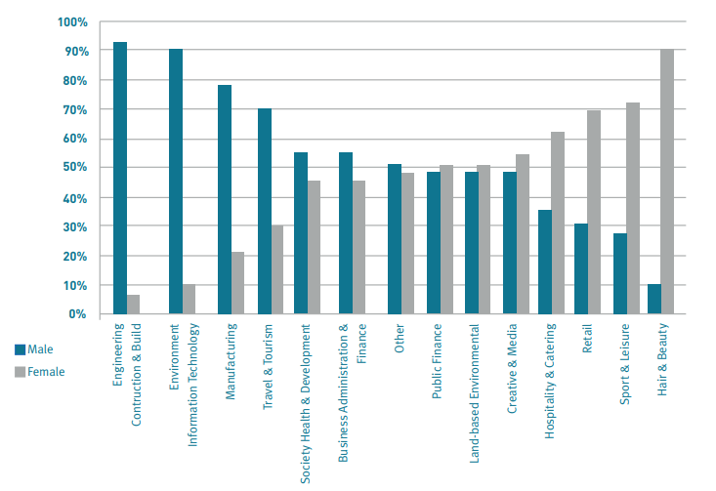

And yet, there is also evidence that significant proportions of young people (14% of boys and 36% of girls) would be interested in trying a non-traditional placement. As noted in the government’s 2011 Social Mobility Strategy, work experience is an under-utilised means to enhance social mobility in the UK. Given the importance of work experience within school to work transitions, its importance is especially high to pupils from backgrounds where family social networks are weak, such as the two million children who live in workless households. Good research shows too that young people from disadvantaged backgrounds have most to gain from work experience which is managed and personalised to stretch aspirations, rather than fall back on comfort zones.
The important fact is that schools would be able to broaden the career horizons of young people by managing work experience more closely. One study looked at how five schools in the West Midlands managed work experience and found that one school, serving a highly disadvantaged area, broke the pattern of social reproduction by adopting a more directive approach to work experience, sourcing placements to fit the most aspirational ambitions of young people following career and progression related discussions. In this case, a much higher proportion of pupils accessed professional placements than was the case with schools with in-takes of similar social characteristics, leading to positive consequences in terms of changing pupils’ ambitions and study intentions. Therefore one can conclude from research that the current model of work experience could be improved to offering young people a much broader range of experiences, challenging pre-conceptions, building better informed decision-making and stretching ambitions.
Historically, UK schools have largely adopted a one size fits all approach to delivering work experience. Young people have commonly undertaken a two-week placement at the end of Year 10. This practice is unlikely to optimise the motivational benefits which two-thirds of teachers see as stemming from placements. The practice, moreover, serves to restrict access to work experience placements as employers face inherent limitations in the numbers of pupils they can accommodate at any one time. More needs to be known about the relative effectiveness of alternative means of workplace exposure, notably career fairs, workplace visits and job shadowing. Perhaps, of greatest importance, there is an urgent need to raise awareness in schools about the existing evidence on the impact of work experience (as well, of course, to increase resources devoted to understanding the depth and breadth of impacts).
Age is also another important factor in understanding the benefit of work experience. We believe, while post-16 work experience is extremely valuable as young people are getting closer to transition fully to labour market, it should be stressed that activity undertaken prior to the age of 16 serves an important purpose in helping young people to make more confident decisions about what and where to study after completing their GCSEs. Consequently, the evidence would suggest that a wide range of workplace experiences (including career talks, workplace visits, job shadowing as well as work experience) over the duration of secondary education will optimise the beneficial effects of employment engagement to career decision-making.
June 2018

