Written evidence submitted Elevation Networks (BYC035)
Executive Summary
- Elevation Networks (EN) is a youth employment charity dedicated to developing the leadership potential in talented young people by partnering with outstanding employers, schools, universities and careers services to create diverse career opportunities.

- As a youth employment charity, it is our view that providing access to good quality work experience and employment support is vital to improving opportunities for young people, particularly those groups of young people who are traditionally disadvantaged and underrepresented within employment and in certain professions.

- Our track record demonstrates that good quality work experience brings positive benefits for young people, improves their social mobility and their competitiveness in the labour market.

- Good quality work experience has the power to change industries by tackling historic inequalities, e.g. gender, or race. Through our Visible Women Campaign we aim to create a world where young women and girls can find role models and mentors in the careers they are interested in working in - regardless of their gender and the stigma attached to male dominated industries. It is vital that women and other underrepresented groups do not feel disheartened before they even embark on a career, due to a lack of confidence or believing thriving misconceptions.

- Secondary research tells us that geography can have a negative impact on the accessibility and availability of work experience opportunities. For example, in areas where we operate (East Midlands and London) there is a marked difference in the proportion of employers offering work experience.

- Through our previous work with NEET groups it is clear that socioeconomic background pose a significant barrier to young people in accessing good quality work experience.

- Through working with employers from the private and public sectors we are aware that young people from minority ethnic backgrounds often do not have access to appropriate types of work experience or support. Many employers and professions currently struggle to recruit candidates from black and minority ethnic backgrounds through their existing networks, often because the employers themselves do not have the knowledge, experience, and resources to target these specific groups.

About Elevation Networks
Elevation Networks (EN) is a youth employment charity dedicated to developing the leadership potential in talented young people by partnering with outstanding employers, schools, universities and careers services to create diverse career opportunities.
EN works with young people aged 11-25, specifically focusing on groups that are underrepresented within the labour market and specific industries: ethnic minorities; women, young people from low socio-economic groups, and young people not in education, employment or training. In 2016/17 we provided 22,600 young people from BAME and underrepresented backgrounds with career information, advice and guidance through our events, programmes and online services.

Providing ‘Good Quality Work Experience’
As a youth employment charity, it is our view that providing access to good quality work experience and employment support is vital to improving opportunities for young people, particularly those groups of young people who are traditionally disadvantaged and underrepresented within employment and in certain professions.
We provide a holistic approach to providing work experience for different groups of young people, recognising that young people from underrepresented backgrounds often face particular challenges, such as facing exclusion from the labour market, encountering prejudice, racism, and unconscious bias, and being ‘overlooked’ by certain professions and industries. Through our ‘theory of change’ we recognise that there is no ‘one size fits all approach’ and that different groups of young people often require different types of workplace encounters that may be collectively defined as ‘work experience’.

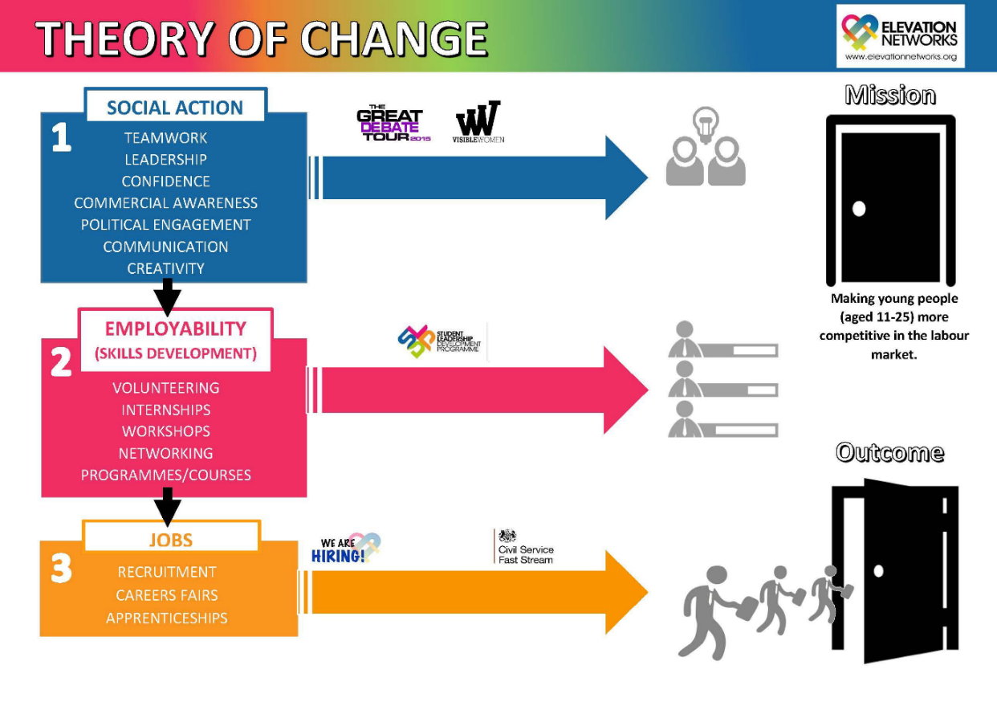
Figure 1 Elevation Networks' Theory of Change Model
Through our ‘theory of change’ (Fig. 1) we provide interventions that support tangible employment outcomes for young people by making them more competitive in the labour market.

Work Experience and Social Mobility
Our track record demonstrates that good quality work experience brings positive benefits for young people, improves their social mobility and their competitiveness in the labour market. Through our programmes and campaigns, employers are encouraged to look beyond their traditional talent pools by engaging with young people from underrepresented backgrounds, such as those from Black, Asian and Minority Ethnic (BAME) female, low-socioeconomic and NEET (not in education, employment or training) groups.

CASE STUDY 1: London 360
In May 2015 Elevation Networks launched London 360˚, a 3-stage ‘job-readiness’ training course for Young Black Males (YBM) aged 16 to 24 living in the London boroughs of Lambeth and Haringey, funded by Trust for London and the City Bridge Trust in partnership with the Black Training and Enterprise Group (BTEG). The imperative behind this initiative was a disproportionate and longstanding high unemployment rate for young black men across London boroughs.

Through the programme, participants received advice on CV and interview skills, demonstrations on live job applications and insight into current vacancies and opportunities to meet entrepreneurs, local employers and national organisations as part of structured workplace encounters.

- The programme supported 177 beneficiaries over 2 years with a focus on supporting unemployed Young Black Males (YBMs) aged 16-24 from London boroughs.
- Elevation Networks partnered with job centres in Tottenham, Enfield, Wood Green, Palmers Green, Finsbury Park, Brixton, Kennington, Clapham and Stockwell. We worked with local and national employers including: Transport for London, The British Army, BT, Goldman Sachs, Barclays, Microsoft, EDF, and JP Morgan.
- 150 (84.7%) of Young Black Male participants are now in employment with organisations including Transport for London, Halifax Bank, and Harrods.

Participant Case Study: ‘Troy’: On the first day of Lambeth 360*, participants are encouraged to complete three self-analysis exercises. Most participants found this day useful, unfortunately, Troy was unable to attend. Even though he seemed promising during the sign-up process, his lack of attendance caused us to believe that he would not return. On the second day, the young people meet with local employers and entrepreneurs. To our surprise, Troy was present and he flourished in this environment. The activities that took place allowed the participants to consider the various employment opportunities available to them. Troy’s bubbly nature translated into great engagement with the speakers and singled him out as a valuable contributor. During the last three days, where participants receive professional mentoring from staff volunteers at JP Morgan, our hope in Troy dwindled. His attendance fluctuated but when he was present, he offered great insight.

On completing the course, Troy has been able to gain full-time employment as a Teaching Assistant. He notified us at every successful stage of his application process: requesting advice and updating us on his progress. He has attributed his new-found role to the support and direction he received whilst participating in Lambeth 360*.

Supporting Industrial Change through Good Quality Work Experience
Our flagship diversity awareness campaign Visible Women (VW) aims to challenge the underrepresentation of women in male dominated industries. This is achieved by building networks, promoting mentoring and championing role models.
Through the Visible Women Campaign we aim to create a world where women and girls can find role models and mentors in the careers they are interested in working in - regardless of their gender and the stigma attached to male dominated industries.
Statistics published by the WISE campaign show that in 2017 women make up less than a quarter (23%) of the STEM workforce, and only 24% of those working in core STEM industries. Women are also underrepresented across a number of core industries, including Engineering (11%), ICT (17%) and Sciences (42%).
Research by the University of Surrey found that:
“Young people hold very strong stereotypes about the types of jobs that are appropriate for men and women. These gender stereotypes pose barriers to stop young people going into non-traditional work. This is because young people use them as the basis for actively selecting themselves into or screening themselves out of the market for certain jobs.”

CASE STUDY 2: Visible Women and HSBC
Elevation Networks established a mutual mentoring scheme with HSBC that strengthens the relationship between both stakeholders, but also works towards a shared vision of supporting young women to achieve their full potential in the working world. The partnership of female undergraduate mentees with existing HSBC graduate mentors, enables the students to develop the necessary professional skills and confidence to take them forward into their careers.

The programme also demonstrates that HSBC’s culture is one of true Diversity, Equal Opportunity and that the Financial Services Industry is very much open to women. It is vital that women do not feel disheartened before they even embark on a career, due to a lack of confidence or believing thriving misconceptions.

The Mentoring Programme
Following our three-stage application process, fourteen female undergraduate mentees were selected and subsequently paired with current HSBC graduates, to mentor them over the course of the three-month programme. The process culminated in an ‘Experience Day’, which was a valuable opportunity to showcase the range of opportunities within HSBC; the International scope, the Diversity; from the prestigious Group Head Office. The Experience Day event took place, and comprised of a final free-format 1:1 session with mentors, a skills session on interview techniques, speeches delivered by senior female management, a Networking Lunch with the HSBC Graduate Population and senior Management, an Interactive Business Game and lastly a programme feedback session.

Outcomes
Five of the mentees successfully progressed on to the HSBC internship, a significant stepping stone towards joining one of the Graduate programmes.

Young People
Elevation Networks understands that geographic locations, socioeconomic backgrounds, ethnicity and gender can all pose significant barriers for young people accessing work experience opportunities.

Geography
Secondary research tells us that geography can have a negative impact on the accessibility and availability of work experience opportunities. For example, in areas where we operate (East Midlands and London) there is a marked difference in the proportion of employers offering work experience. In London, 46% of employers have provided work experience opportunities for one or more young people, compared to just 34% in Nottinghamshire and Derbyshire.
We also have evidence from our London 360 programme that unemployed young black men are often discouraged from engaging in work experience away from their immediate neighbourhoods (e.g. within their Borough). It is therefore essential that young people from underrepresented groups have access to work experience opportunities within their locality. We are currently working with a number of employers, such as the Civil Service, who have implemented measures to ensure that opportunities are available to people from diverse backgrounds across different UK regions.

Socioeconomic Background
Through our previous work with NEET groups it is clear that socioeconomic background can pose a significant barrier to young people in accessing good quality work experience. Through our London 360 programme we have worked to bridge the gap between employers and underrepresented groups. By working with Job Centre Plus and other agencies we connected young people who were disengaged from the labour market with local employers and entrepreneurs who provided workplace encounters and ‘real life’ work experience.
We are also working with the Civil Service to attract, coach, and recruit young people from low-socioeconomic backgrounds for Civil Service Fast Track Apprenticeship, Diversity Internship, and Fast Stream Graduate Programmes. In 2016, only 1.9% of young people from low-socioeconomic backgrounds were successful in the Civil Service Fast Stream recruitment process, compared to 4.2% from high-level socioeconomic backgrounds. Through our diversity outreach campaign we are currently providing Civil Service insight days for young people from underrepresented backgrounds. In 2016/17 28 people successfully secured positions on the Civil Service Fast Stream diversity internship programmes, graduate scheme and Fast Track Apprenticeship programme.

Ethnicity
Ethnic background can pose a barrier to young people in accessing work experience. In our report Race to the Top “The Experience of Black Students in Higher Education, published in 2012, we identified that 60% of university students had undertaken paid work experience. However, opportunities for young people from black and minority ethnic backgrounds are often more limited without/prior to attending university. Outcomes from our London 360 programme for young black males aged 16-24 who were NEET showed that one in ten participants had never had any experience of employment.
Through working with employers from the private and public sectors we are aware that young people from minority ethnic backgrounds often do not have access to appropriate types of work experience or support. Many employers and professions currently struggle to recruit candidates from black and minority ethnic backgrounds through their existing networks, often because the employers themselves do not have the knowledge, experience, and resources to target these specific groups. Elevation Networks have worked with employers in a variety of sectors, including the Civil Service, teaching profession, investment banking, financial regulation, and professional services in order to overcome some of these challenges.
By working in collaboration with employers, we have co-designed successful work experience interventions that improve outcomes for young people from minority ethnic backgrounds. Employers also benefit from the added value of having a more diverse talent pipeline.

CASE STUDY 3: Elevation Networks and the Financial Conduct Authority

Through our flagship campaign, Visible Women, Elevation Networks co-designed and delivered a bespoke insight week for 25 first-year female students with a focus on those from BAME backgrounds and low-income households. The week took place at the FCA head office providing practical work experience, job shadowing and employability training opportunities.

From the start, Elevation Networks and the FCA collaborated to deliver a programme which matches the needs of young people with the aspirations of both organisations. Students and recent graduates from Elevation Networks have been at the forefront of programme design, planning and delivery, whilst recent graduates from the FCA’s graduate development programme have been involved with the delivery of insight activities including work shadowing and networking.

No previous work experience existed, so this intervention was designed as a pilot and is now a permanent opportunity offered to students as a result of our partnership. The Spring Week internship has provided an innovative solution to common problems faced by employers and young people. Firstly, there has been a historic underrepresentation of women and ethnic minority groups in certain industries, particularly at board level.

Our innovative partnership provides a truly blended approach to work experience built on best practice providing opportunities for work shadowing, networking, site visits, real-life case studies and skills development, including those needed to create successful applications and the qualities needed to succeed in the workplace.

In 2016/17:

● A total of 47 young people attended our FCA career events and work experience opportunities during the 2016/17 academic year.
● The FCA has recently reported an increase in its BAME graduate cohort, rising to 30% in 2016 compared to 25% in the previous year.
● Almost half (46%) of our participants have been accepted for roles within financial services and investment banking.

June 2018

WISE (2017) Women in STEM Workforce 2017, Leeds, Wise Campaign, Available from: https://www.wisecampaign.org.uk/resources/2017/10/women-in-stem-workforce-2017
Millward, L., Houston, D., Brown, D., Barrett, M. (2006) Young People's Job Perceptions and Preferences, DTI, London, Available from: https://www.warwick.ac.uk/fac/soc/ier/ngrf/euskills/module1/sources_careers_information/who_influences_report.pdf
Careers and Enterprise Company (2016) Understanding the careers cold spots, London, Careers and Enterprise Company, Available from: https://www.careersandenterprise.co.uk/sites/default/files/download-files/cold_spots_report_2016.pdf
Civil Service (2016) Civil Service Fast Stream and Early Talent Report, London, Civil Service HR, Available from: https://assets.publishing.service.gov.uk/government/uploads/system/uploads/attachment_data/file/694028/FSET_Annual_Review_2016.pdf_23_March_Final.pdf
Trust for London (2017) Moving on Up Learning Report, London, Trust for London, Available from: https://www.trustforlondon.org.uk/publications/moving-learning-report/

