Written evidence submitted by the Edge Foundation (BYC005)

A. Why is work experience so important?
- Employers are reporting significant and growing skills shortages within the economy. For instance, the British Chambers of Commerce found in Quarter 1 of 2018 that 60% of services firms and 69% of manufacturing firms were experiencing recruitment difficulties. The CBI similarly found that 75% of employers expect that they will need more staff with higher skills in the years ahead, but 61% of businesses were not confident that they will be able to recruit enough high-skilled employees.

- At the same time, the latest figures from ONS show that 322,000 young people aged 16-24 are NEET and unemployed.

- This mismatch presents significant challenges both for young people who are keen to find work to develop their lives and careers, and for employers who are crying out for skilled workers.

- Employers are also clear about what is needed to address this mismatch. CBI research sets out that the biggest drivers of success for young people are attitudes and attributes such as resilience, enthusiasm and creativity – 86% rated attitude and 68% aptitude as a top attribute, just 34% said the same of formal qualifications.

- This is reinforced by our own research, in partnership with Education and Employers and the National Education Union, which looked across a wide range of reports at the skills and attributes that employers look for. Those most cited included problem solving, communication, team management, confidence, drive and resilience.

- These are exactly the kinds of skills that young people gain through work experience specifically. This is borne out by the Department for Education’s own Employer Perspectives Survey, which showed that almost two thirds (65%) of employers said that work experience was significant or critical when recruiting. By contrast, over half (52%) said that academic qualifications were of little or no value when recruiting. (Fig 1)

- In our experience, work experience is intrinsically linked to social mobility in two key ways. Firstly, it opens young people’s eyes to a wide range of different career options that they might not otherwise have considered and can help them to meet role models or individuals whose career journeys they wish to emulate. Secondly, it helps them to build the social capital that is essential in developing a successful career, for instance through references, mentoring and the development of a network of contacts.

Fig 1.
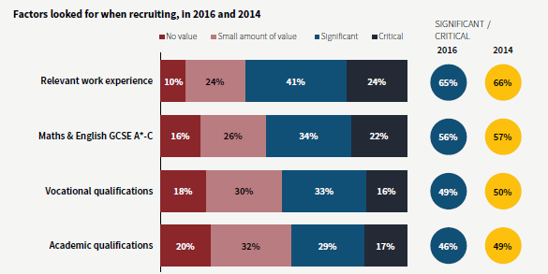
B. How can work experience be improved?
- It is important to broaden out this debate from ‘work experience’ in the traditional sense to ‘experience of work’ in the widest sense. We think that it is important for you to gain these kinds of experiences in a variety of ways throughout your time at school, further and (where relevant) higher education.

- The curriculum, careers guidance and employer engagement are too often thought about as three separate themes, if the latter two are thought of at all. The provision of guidance in schools is patchy and in many cases poor, and this creates a real opportunity for step change in this area, building on the excellent work done recently by the Gatsby Foundation on the benchmarks for good careers guidance.

- Wherever possible, good quality careers guidance should include employers – as mentors, speakers, visit hosts or case studies, and so careers guidance and employer engagement should go hand in hand.

- We think that this approach should go significantly further to create a fully integrated 14-19 curriculum that relates learning directly to the wold of work. This will create opportunities to include guidance and employer experiences throughout your lessons rather than segregating them in brief PSHE or even briefer tutor periods. You might be inspired by hearing from an employer about their approach to recruitment in Business Studies, work with a local business on a project in science or write a persuasive covering letter in English.

- Even where schools do provide guidance or employer engagement activities, too often they do not have the impact they might because they are seen as individual separate instances and not part of an overall journey. Everyone should have a clear and planned programme of career and employer interventions across the integrated 14-19 phase so that you can clearly see how these fit together.

- In the early stages of your time at school, you should be given the opportunity to sample a wide range of different jobs and industries through job profiling, job shadowing, workplace visits and employer talks. The focus should be on broadening horizons, raising aspirations and encouraging you to find your passion.

- Across the remainder of the 14-19 phase, you should have access to planned careers and employer interventions every year that build on each other and relate directly to your areas of interest. We support the call from the All Party Parliamentary Group on Education to make work experience a mandatory part of that process - not the one-size-fits-all week that existed in the past but an entitlement to high quality experiences through work placements, job shadowing and masterclasses for every young person.

- As you near the end of the 14-19 phase, paid internships can be an excellent way for you to not only hone your workplace skills but also make contacts that can lead on to a paid job after school, college or university. Mentoring, by school professionals or employers, is also a powerful approach throughout this phase to help you to reflect on what you are learning and plan your future. Recent research by the Education and Employers Taskforce has shown that mentoring is one of the most effective activities in supporting future employment, being linked to an 18% wage premium.

- We recognise that planning and delivering high quality career advice and employer engagement takes time and also skills that a school’s core staff might not necessarily have. Careers guidance and employer engagement must be properly funded in schools without having to reduce teaching budgets. If the former funding for Connexions had gone to schools, each should have received more than £100,000 to make a real difference in this area:
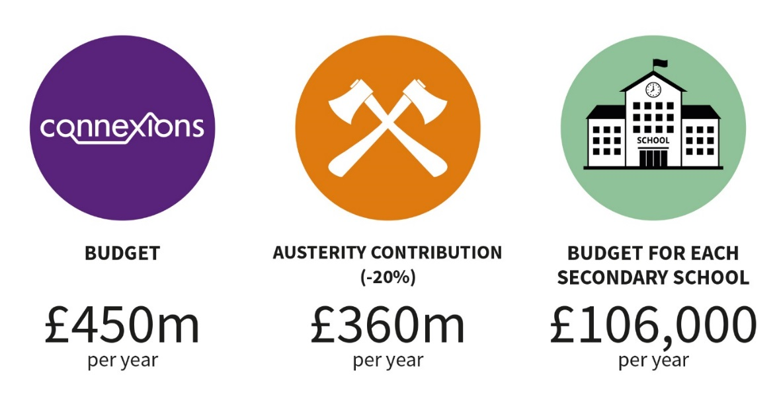
C. What does good practice look like?
Real World Learning – School 21 (Stratford, London)
- School 21 is an innovative Free School for 3-18 year olds based in Stratford in East London, which focuses holistically on the development of pupils – head, heart and hand. There is a strong focus on wellbeing and the development of oral communication skills throughout the school to help pupils express themselves and reflect on their experiences.

- The school also focuses very strongly on ensuring that what it teaches young people is highly relevant to the real world and each term culminates in an exhibition in which their work is on show to members of the school and local community. The school has chosen to prioritise employer engagement as the ‘ninth GCSE’ for their pupils, putting the funding and curriculum time into this area that would have gone into that additional subject. They make use of those employer links through the Real World Learning Programme, which sends every student in Year 10 to an employer for half a day per week to undertake a real project with a tangible result for the business.

- Pupils have worked with a local hotel to redesign their children’s menu, with a major bank to improve their staff coaching, with a famous publisher to improve the way they appeal to children and even with government departments to help solve policy problems. This brings real value to the business, but most importantly helps pupils to develop their skills in the workplace and make valuable employer links.

- School 21 goes further to integrate relevance into lessons through cross-curricular working and project based learning. Teachers are encouraged to think about how to use projects as an exciting way to bring their subject alive. For instance, collaborating across the English and maths departments, students worked with a local activist group fighting against plans to build three concrete factories in the Olympic Park. They created a report bringing together evidence against the planning application, using mathematical modelling to predict air pollution and writing persuasively as local residents. As well as providing an authentic focus for their English and maths development, the report also had a real world impact as the planning application was stopped, providing a source of real pride for the students and school.

HANNAH BARNETT, Senior Programme Officer, School 21: “Making what young people learn relevant is absolutely crucial to maintaining their interest and ensuring that they develop the skills they need for their future career. This has to be authentic in order to work. Real World Learning gives all of our pupils the chance to have these experiences in the workplace, but we also strive to bring that relevance into all of our lessons through employer engagement and exciting crosscurricular projects.”
High Quality Work Placements – Sir Frank Whittle Studio School (Lutterworth)
- The Sir Frank Whittle Studio School connects education with employment by supporting its students to undertake weekly work placements as an integral part of the curriculum. Year 10 pupils study a range of academic qualifications including GCSEs, BTECs and a Higher Project Qualification alongside one day per week gaining real work experience with a local employer. In Sixth Form, this is extended to two days per week of work experience, plus an Extended Project Qualification.

- Having over 140 business partners supporting the school through offering work experience ensures that students are suitably matched to their placements. This requires dedicated resource and support.

- Alongside this, the school runs a comprehensive Readiness for Work Programme, which includes mock interviews, presentation skills, motivational talks and employer tours amongst many other activities. This enables the students to prepare for and get the most out of their extended work experience placements.

- All of this activity helps to motivate students by showing them how the curriculum links directly to the skills they will need in the workplace. This was recognised in the school’s 2017 Ofsted report, which stated that “pupils are highly motivated and exceptionally well informed about the world of work and the range of opportunities available to them.”

OWEN, a Year 12 engineering student, joined the school in Year 10 and is studying for a BTEC Level 3 Extended Diploma in Engineering. Owen’s passion is trains and his ambition is to be a train driver.
The school successfully secured placements for Owen at Network Rail and Bombardier before moving on to a two day per week placement with East Midlands Trains.
Owen said “I have thoroughly enjoyed each of my work placements. It was great working on a full scale railway with EMT, learning how trains are built at Bombardier and then learning about the operations side at Network Rail. Work experience has increased my confidence, improved my customer service skills and I feel I have really good employability skills now, especially for the railway. My work experience has given me a good taste of what working life is like.”

Masterclasses, Mentoring and Internships – Career Ready UK
- Career Ready is a charity operating across the UK to link employers with colleges and schools to prepare young people for the world of work. They give teenagers, particularly from lower income families the confidence, skills and networks to fulfil their potential.

- Their programmes are based on four key employer engagements that make a difference to young people – masterclasses, mentoring, workplace visits and internships. All of these are delivered by business volunteers. The internship, in particular, causes a sharp increase in students’ grasp of the skills and behaviour necessary for career success.

- Career Ready began in 2002, working with professional and financial services companies through their community programmes, and now works with businesses across many growth sectors including construction and logistics. For the past two years 97% of students on their core programme have gone on to a positive destination, increasingly work or apprenticeships rather than university.

YEHYA HAWILA, Degree Apprentice, Costain: “Before I engaged with Career Ready I wasn’t at all confident about what I wanted to do in the future. My internship at Costain Skansk JV was the turning point. Getting first-hand experience of the world of work before actually going into work has prepared me for the challenges you face at work and how they differ from school. I’ve now got a strong foundation on which to build my future, and I’ve already been lucky enough to gain a place on a degree apprenticeship at Costain.“
Fig 3.
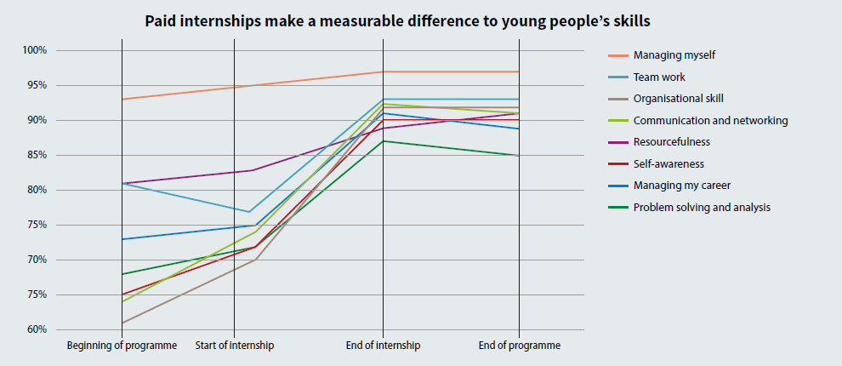

Work Experience…for Teachers – Give Yourself the Edge
- The Edge Foundation piloted this model in Nottingham in 2015-16 and we have expanded the approach to Nottingham, Derby and the North East. Teachers have the opportunity to engage in a short externship in a business. Teachers are introduced to what the business does, they explore its culture and ethos and also some of the ‘hidden jobs’ in different departments. During the day, teachers meet several employees from across the business working in a variety of roles and levels.

- The externship gives teachers an authentic and up to date experience of an employer based in the local area which helps them to showcase opportunities to their pupils. Employers have the opportunity to embed their relationship with schools as a pipeline for future staff and to show their commitment to the community.

- When the teachers return to their schools, they develop a curriculum project based on their experience, helping to make their teaching more relevant and to embed learning about careers and the world of work into lessons.

At their externship at British Gypsum, Alex Booth, The Farnborough Academy (second from the left): “I was amazed by the sheer scope of jobs available, which is really exciting for my students. It was also fascinating to see the range of scientific jobs and applications were used for what seemed at first to be a simple product manufacture. It can show our pupils how the curriculum can be applied in many different ways.”
Rachel Justice, The Farnborough Academy (Far left) “It was particularly interesting to meet the business’s Principal Scientist as part of the externship. He left school with a few GCSEs, came to British Gypsum and has since been sponsored through a degree, Masters and PHD and now works on global projects. It really opened up in my mind different career routes and possibilities for my students.”

June 2018

British Chambers of Commerce, Quarterly Economic Survey, Quarter 1 2018 - http://www.britishchambers.org.uk/policy-maker/economic-data/quarterly-economic-survey/
CBI / Pearson Education and Skills Survey 2017 - http://www.cbi.org.uk/news/skills-needs-must-now-drive-reforms-cbi-pearson-education-and-skills-survey/
ONS, Young People not in education, employment or training (May 2018) - https://www.ons.gov.uk/releases/youngpeoplenotineducationemploymentortrainingneetukmay2018
CBI / Pearson Education and Skills Survey 2017 - http://www.cbi.org.uk/news/skills-needs-must-now-drive-reforms-cbi-pearson-education-and-skills-survey/
Research to be published by Edge, Education & Employers and the National Education Union in 2018
IFF Research for DfE, UK Employer Perspectives Survey 2016 - https://www.gov.uk/government/publications/employer-perspectives-survey-2016
http://www.gatsby.org.uk/education/programmes/good-career-guidance

